Year 11 Semester 2 Examination, 2007

Solutions Booklet

PHYSICS

Name: ___________________________________

Teacher: ___________________________________

Time allowed for this paper
Reading time before commencing work: Ten minutes
Working time for paper: Three hours

Material required/recommended for this paper
To be provided by the supervisor
This Question/Answer Booklet
Physics: Formulae, Constants and Data Sheet (inside front cover of this Question/Answer Booklet)

To be provided by the candidate
Standard Items: Pens, pencil, eraser, correction fluid, ruler, highlighter
Special Items: MATHOMAT and/or Mathaid, drawing compass, protractor, set square and calculators satisfying the conditions set by the Curriculum Council for this subject.

Important note to candidates
No other items may be taken into the examination room. It is your responsibility to ensure that you do not have any unauthorised notes or other items of a non-personal nature in the examination room. If you have any unauthorised material with you, hand it to the supervisor before reading any further.
Structure of this paper

Section | Number of questions | Number of questions to be attempted | Marks available
A: Short Answers | 15 | ALL | 60
B: Problem Solving | 7 | ALL | 100
C: Comprehension and Interpretation | 2 | ALL | 40

Instructions to candidates

1. Write your answers in the spaces provided in this Question/Answer Booklet.
2. You may remove the enclosed Physics: Formulae, Constants and Data Sheet from the booklet and use as required. This sheet is to be handed in at the end of the examination.
3. Your answers to questions involving calculations should be evaluated and given in decimal form. It is suggested that you quote all answers to three significant figures, with the exception of questions for which estimates are required. Despite an incorrect final result, you may obtain marks for method and working, provided these are clearly and legibly set out.
4. Questions containing the specific instructions “show working” should be answered with a complete, logical, clear sequence of reasoning showing how you arrived at your final answer. For these questions, correct answers which do not show full working will not be awarded full marks.
5. Questions containing the instruction “estimate” may give insufficient numerical data for their solution. You should provide appropriate figures to enable an approximate solution to be obtained.
6. When descriptive answers are required, you should display your understanding of the context of a question. An answer which does not display an understanding of Physics principles will not attract marks.
SECTION A: Short Answers
Marks Allotted: 60 marks out of total of 200 marks (30%)

Attempt ALL 15 questions in this section. Each question is worth 4 marks. Answers are to be written in the space below or next to each question.

1. Explain the difference between a virtual image and a real image.
- A virtual image is created from where the rays of light appear to come. [1]
- A virtual image cannot be projected on a screen. [1]
- A real image is created where actual rays of light come to a focus. [1]
- A real image can be projected on a screen. [1]
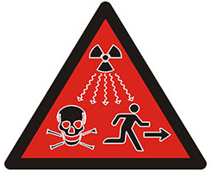
2. The half-life of a particular radioactive source is 27.0 minutes. A 10.0 g sample of this source is observed to have an activity of 72.0 Bq.
a. Calculate the time it will take for the activity of this sample to decrease to 9.00 Bq.
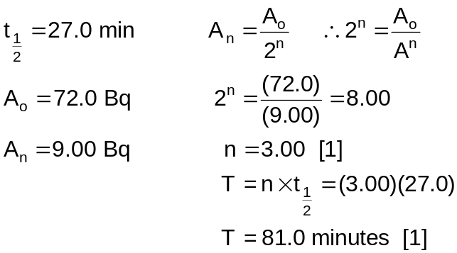
b. State how the half-life would be affected if the radioactive source were cooled to a low temperature. Give one reason for your answer.
- Half-life would not be affected by temperature. [1]
- As the decay process is dependent on nuclear forces not the average kinetic energy of the particles. [1]
3. An elevator car has a mass of 1.60 x 10³ kg and it is carrying four passengers with a total combined mass of 2.00 x 10² kg. A friction force of 4.00 x 10³ N acts constantly to retard its motion upward. What power is delivered by the motor to lift the elevator car at a constant speed of 3.00 m s⁻¹?
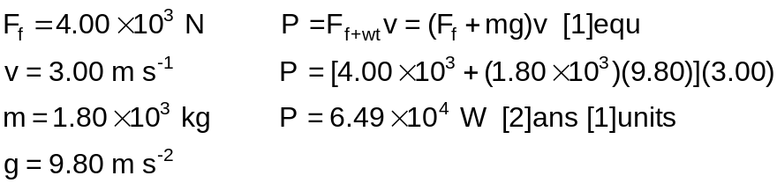
4. Your Physical Education teacher throws a cricket ball to you at a certain speed, and you catch it. The teacher is now going to throw a medicine ball to you; its mass is ten times the mass of the cricket ball. You are given the following choices, you can have the medicine ball thrown with:
a. the same speed as the cricket ball,
b. the same momentum,
c. the same kinetic energy.
Rank these choices from; easiest to catch, to, hardest to catch.
b c a
b>c [2], b>a [1], c>a [1]
5. For a convex lens, is the focal point the same as the focus point? When are they the same and when are they different?
- Focal point is the point at which a ray of light parallel to the principal axis will either pass through the principal axis, or the point where it appears to cross the principal axis. [1]
- The focus point is the point at which the image appears. [1]
- They are the same when a distant objects focuses at the focal point of a convex lens. [1]
- They are different when images are virtual or form at any place beyond the focal point. [1]
6. It is well known that objects viewed under water with the naked eye appear blurred and out of focus. However, a scuba diver using a mask has a clear view of underwater objects. Explain how this works by illustrating your understanding of the term “refractive index”.
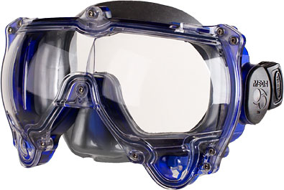
- Human eyes are adapted to bend light at the cornea/air interface by the correct amount to enable the lens to focus the light on the retina. [1]
- When the eye is opened underwater there is a cornea/water interface. [1]
- The water has a higher refractive index than air so less bending occurs and the lens cannot focus the image. [1]
- A scuba mask maintains a cornea/air interface by trapping air around the eye. [1]
7. Two campers wish to start a barbecue fire, in an approved location, during a clear winter’s day. One camper is nearsighted and one is farsighted. Whose glasses should be used to focus the sun’s rays onto some paper to start the fire? Explain your choice.
- Nearsighted people need concave lenses to correct their vision. [1]
- This type of lens will diverge the rays from the sun so they would not be appropriate. [1]
- Farsighted people need convex lenses to correct their vision. [1]
- This type of lens would converge the suns rays to a point so they would be the ones to use. [1]
For the next THREE questions, circle the letter in front of the correct answer
8. Which of the following is the reaction force to the gravitational force acting on your body as you sit in a chair?
a. the normal force exerted by the chair.
b. the force you exert downward on the seat of the chair.
c. the gravitational force of your body acting on the Earth.
d. none of these forces.
9. You are talking by interplanetary telephone to your friend, who lives on the Moon. He tells you that he has just won one newton of gold in a contest. Excitedly, you tell him that you entered the Earth version of the same contest and also won a newton of gold! Who won the most gold?
a. your friend.
b. you.
c. the same amount of gold was won by both of you.
10. The same potential difference is applied to the two light bulbs shown below. Which one of the following statements is true?
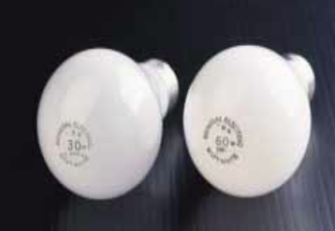
a. The 30 W bulb carries the greater current and has the higher resistance.
b. The 30 W bulb carries the greater current, but the 60 W bulb has the higher resistance.
c. The 30 W bulb has the higher resistance, but the 60 W bulb carries the greater current.
d. The 60 W bulb carries the greater current and has the higher resistance.
11. In a cathode ray tube of a TV set, the measured beam current is 30.0 mA. How many electrons strike the tube’s screen every 40.0 s?
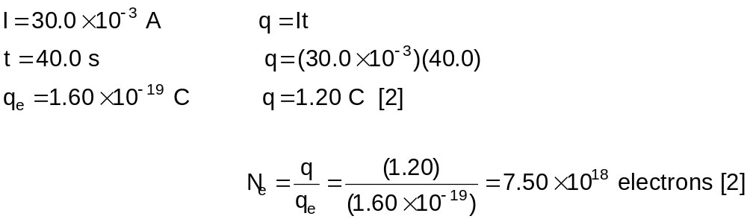
12. Suppose that you wish to make a uniform wire out of 1.00 g of copper, which has a density of 8.92 x 10⁶ g m⁻³, and a resistivity of 1.68 x 10⁻⁸ Ω m. If the wire is to have a resistance of 0.500 Ω, and if all of the copper is to be used, what will be:
a. the length, and
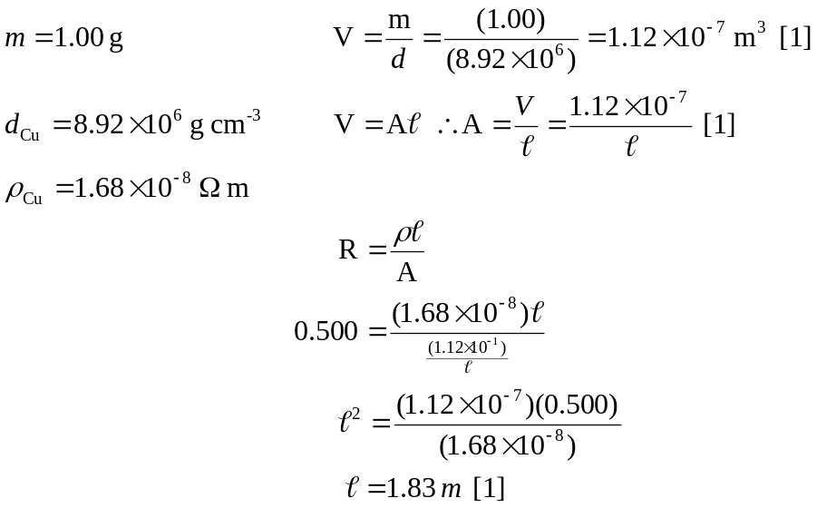
b. the diameter of this wire?
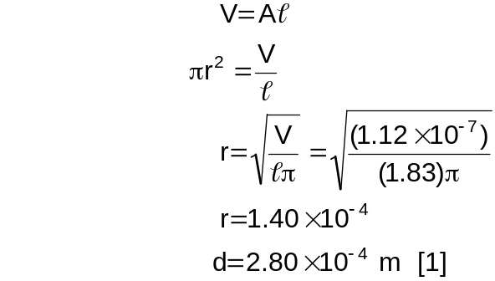
13. Four 1.50 V, AA batteries connected in series are used to power a transistor radio. If the batteries can move a total charge of 2.40 x 10² C, how long will they last if the radio has a resistance of 2.00 x 10² Ω?
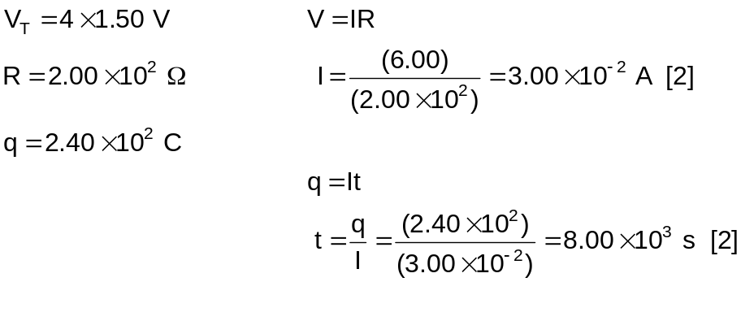
14. At school last week, during the day, the temperature was 26°C. Is this twice as hot as a day when the temperature is 13°C? Explain.
- As the temperature scale extends to 273°C below zero [1]
- the temperature of 26°C is not twice as hot as 13°C. [1]
- 26°C is actually 299 K. [1]
- While 13°C is actually 286 K. [1]
15. Suppose some cold water at 30°C is mixed with some hot water at 90°C. At the molecular level explain what is happening as the temperature reaches equilibrium? No calculations are required.
- The molecules of the 30°C cold water are, on average, vibrating less than the molecules of the 90°C hot water. [1]
- The molecules are colliding with elastic collisions. [1]
- So the molecules with the greater average kinetic energy pass some of their energy on to the molecules with a lower average kinetic energy. [1]
- At equilibrium there will be the same average kinetic energy for both samples of water. [1]
SECTION B: Problem Solving
Marks Allotted: 100 marks out of total of 200 marks (50%)

This section contains 7 questions. You should answer ALL of the questions and show full working.

Answer all questions in the spaces provided.

1. [16 marks]
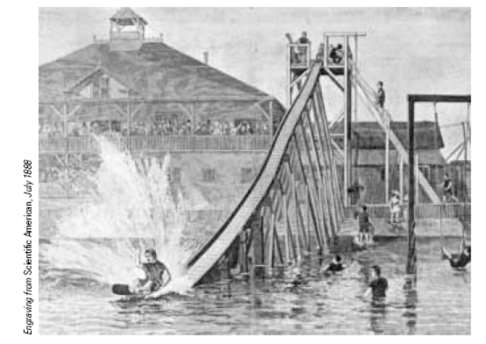
Consider the 1887 water slide shown in the diagram below. A rider on a small sled with a total mass 80.0 kg, can push off to start at the top of the slide
(point A) with a speed of 2.50 m s⁻¹. The chute was 9.76 m high at the top, 54.3 m long and 0.51 m wide. Along its length, 725 wheels made friction negligible. Upon leaving the chute horizontally at its bottom end (point C), the rider skimmed across the water for as much as 50 m, “skipping along like a flat pebble”, before coming to rest.
A
B
C

a. Find the speed of the sled and rider at point C.
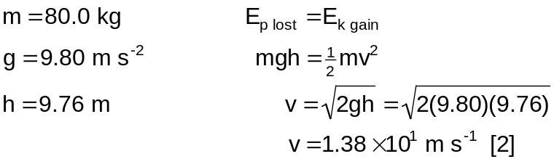
[2 marks]
b. The force of the water friction behaves as a constant retarding force acting on the sled. Calculate the work done by water friction in stopping the sled and rider.
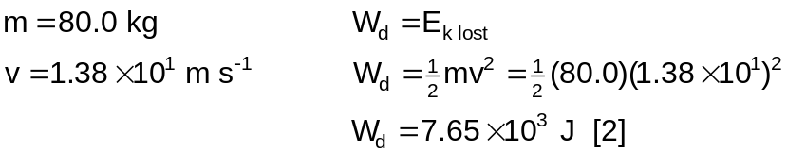
[2 marks]
c. Estimate the magnitude of the average force the water exerts on the sled as it slows down to a stop.
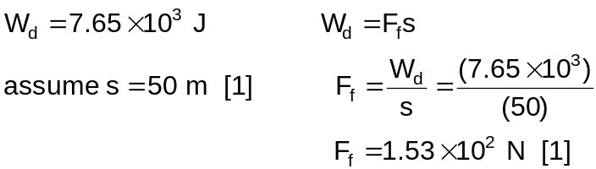
[2 marks]
d. Estimate the angle of the chute?
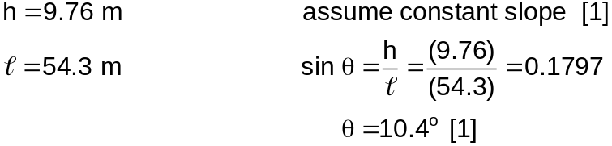
θ
[1 mark]
e. Draw a free body diagram showing the forces acting on the sled and rider at point B?

F_{normal reaction}[1]
_{resistance}
[1]
F_{air resistance}

F_{gravity}
[1]

[2 marks]
f. Using your answers to part d) and e) determine the magnitude of the force accelerating the sled down the chute at point B.
θ
F_{w}
F_{accn}
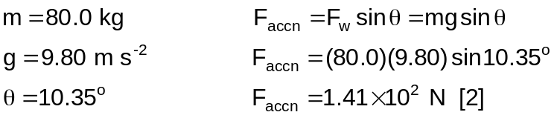
[2 marks]
g. Suppose just as the sled was taking off the boy drops a marble over the edge of the chute on to the ground below. Estimate the time taken for the marble to hit the ground.
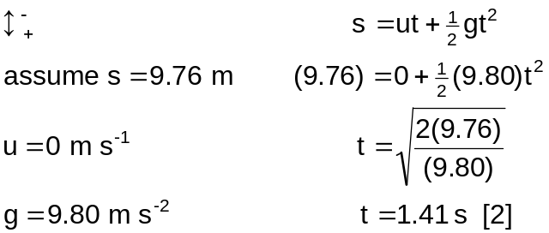
[2 marks]
h. How does the time you calculated in part g) compare to the time taken for the sled to go from point A to point C?
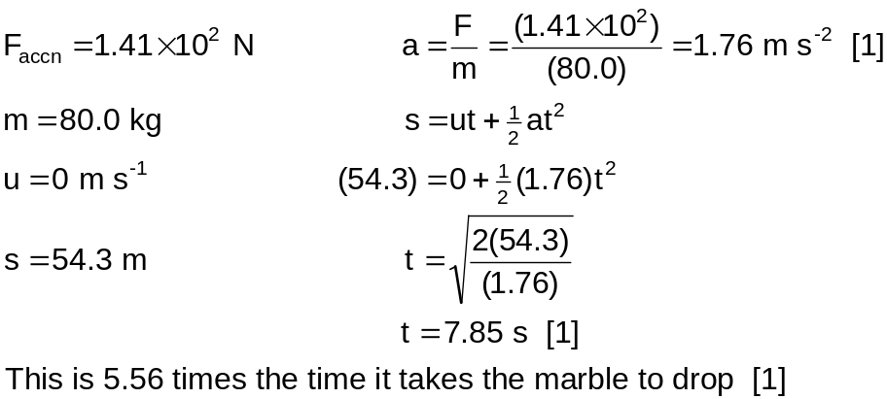
[3 marks]
2. [ 9 marks]
Heidi is looking at a diamond from the Argyle Diamond Mine with a jeweller’s loupe (hand lens), which has a 12.5 cm focal length lens. The loupe forms a virtual image 30.0 cm from the lens.
a. Is the lens in the loupe convex or concave? Explain.
- Convex. [1]
- As the image from a close object in a convex lens is magnified and upright. [1]
[2 marks]
b. The magnification on the lens is marked as “x10”. Is this the correct value? Explain.
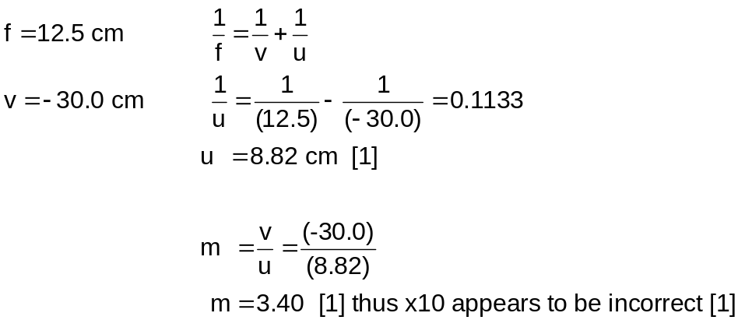
[3 marks]
c. Is the image upright or inverted?
- Image is upright. [1]
[1 mark]
d. Construct a ray diagram for this arrangement.
[1] ray 1
[1] ray 2
[1] image

[3 marks]
3. [18 marks]
The graph below shows the results of an experiment in which some ice is being heated from -30°C to 120°C.
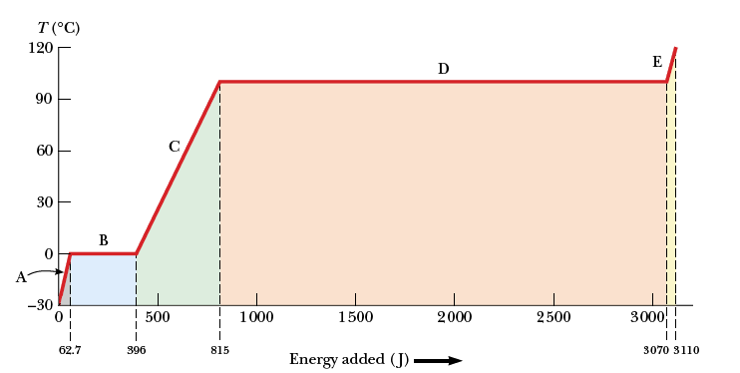
a. Complete the table below to describe what is happening at each stage of the graph.
Stage | Energy added  (J) | Increasing /Decreasing / Same
Stage | Energy added  (J) | Total Internal Energy | Average kinetic Energy | Total Potential Energy
A | 62.7 J | Increasing | Increasing | Same
B | 333.3 J | Increasing | Same | Increasing
C | 419.0 J | Increasing | Increasing | Same
D | 2255.0 J | Increasing | Same | Increasing
E | 40.0 J | Increasing | Increasing | Same
[1] [1] [1] [1]
[4 marks]
b. Using the results from section A of the graph determine the mass of iced used.
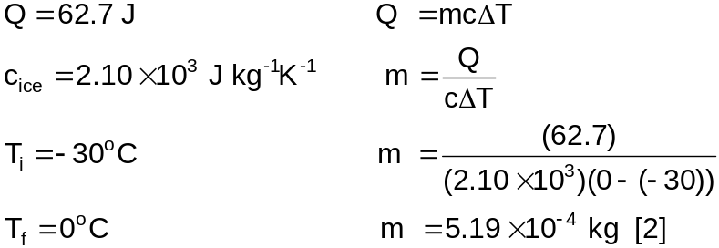
[2 marks]
c. Do you think it would have be better to use the results from stage A or stage C to determine the mass of ice? Explain.
- It would be better to use stage C to determine the mass. [1]
- As the difference in temperature is greater resulting in less percentage error in reading the data off the graph. [1]
[2 marks]
d. Use the graph to explain why it would be much more damaging to exposure your skin to steam at 100°C than it would be to expose it to water at 100°C.
- If your skin is exposed to steam at 100°C the steam will give off significant quantities of latent heat of vaporisation to your skin, and then it will be water at 100°C
- Water at 100°C will give off specific heat of water, which is much less than latent heat.
[2 marks]
e. From the graph determine the latent heat of vaporisation for the water and the latent heat of fusion of the ice?
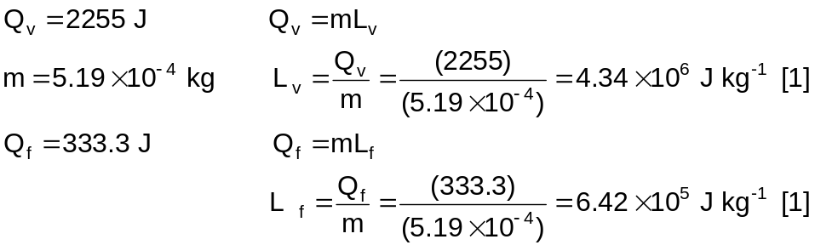
[2 marks]
f. Why do you think that the latent heat of vaporisation for a given substance is usually somewhat higher than the latent heat of fusion?
- The quantity of energy required to loosen the bonds between water molecules from the solid phase to the liquid phase is relatively less than the energy required to separate the molecules from the liquid to the gaseous phase. [1]
[1 mark]
g. Suppose the same process of adding energy to the ice cube is performed as discussed above, but we graphed the internal energy of the system as a function of energy input. Sketch what this graph would look like?
Internal Energy
Energy Input
[2]

[2 marks]
h. Calculate the slopes for the A, C, and E portions of the graph. Rank the slopes from least to greatest and explain what this ordering means.
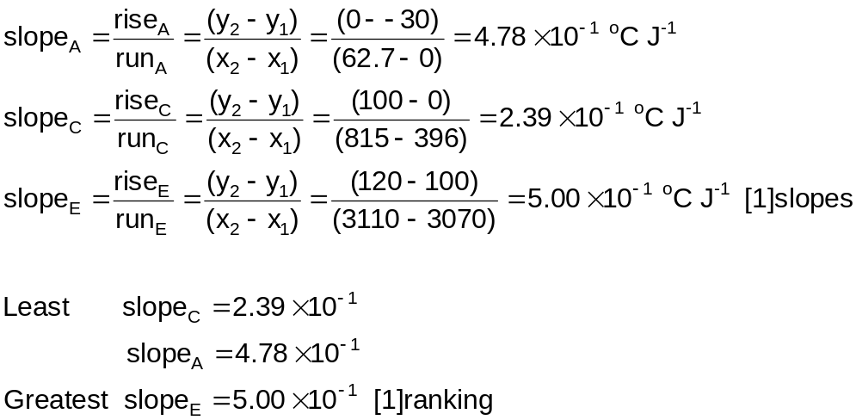
- The slope is the ratio of the temperature change to the amount of energy input. Thus, the slope is proportional to the reciprocal of the specific heat. Water, which has the highest specific heat, has the smallest slope. [1]
[3 marks]
4. [21 marks]
For a Physics practical test you have been supplied with the following items: A 12.0 V power pack, dry cells (batteries), a voltmeter, an ammeter, a rheostat, some insulated connecting wires, some nichrome wire, switches, a polystyrene cup and lid, a thermometer and resistors of 10.0 Ω, 22.0 Ω and 47.0 Ω. With these items you are to conduct a number of simple experiments.
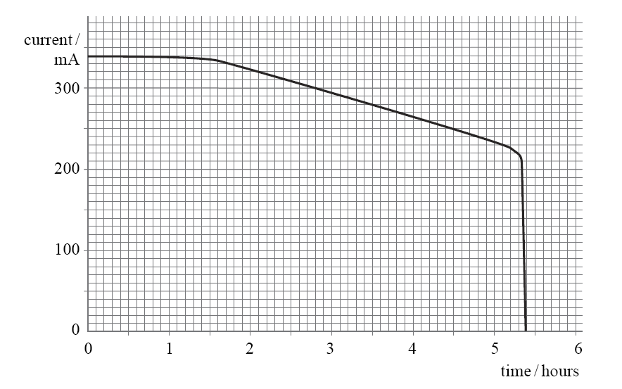
For the first experiment, you used a simple series circuit to test and compare different types of dry cells. The circuit consisted of the cell being tested, an ammeter and a resistor. The graph below shows the results for one cell, which was left on test until it failed completely.
Current Provided by a Dry Cell Over a Period of Time
A
B
C
The emf of the cell at the start of the test was 1.60 V.
a. Calculate the total resistance in the circuit. [2 marks]
V = I R
from graph I = 0.34A [1] thus R = 4.7 Ω [1]
b. Use the graph above to estimate the total quantity of charge that flowed in the circuit during the test. [2 marks]
Total charge is area under the graph [1]
Approx 5700C [1]

The average emf provided by the cell during the test was 1.40 V.
c. Calculate the total work done by the cell.
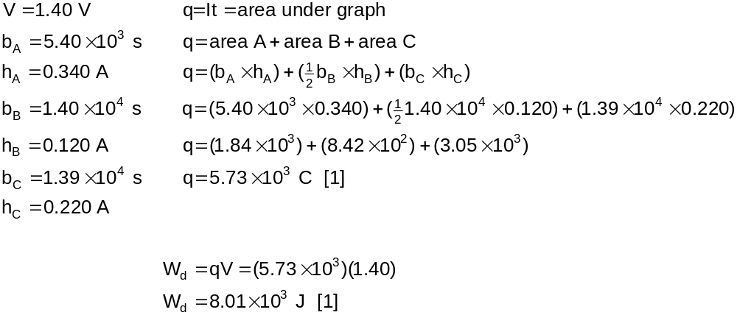
[2 marks]
You now set up a circuit that consists of the three resistors in parallel with each other and in series with the nichrome wire, an ammeter to measure the circuit current and a voltmeter to measure the potential drop across the nichrome wire, and a main switch. The whole circuit is powered by a 12 V power supply.
d. Draw a diagram of the circuit that you set up.
A
V
12.0 V
10.0 Ω
22.0 Ω
47.0 Ω
[¹/₂] parallel
[¹/₂] nichrome
[¹/₂] meters
[¹/₂] switch
nichrome wire

[2 marks]
e. When the switch is closed, the ammeter reads 1.80 A. Determine the resistance of the nichrome wire.
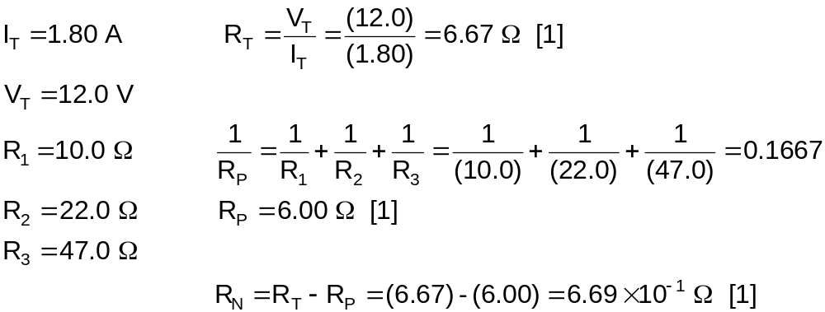
[3 marks]
f. Why is it necessary for a switch to be placed in the circuit?
- The nichrome wire heats up as current flows through it. [1]
- Switching off the circuit prevents the wire from heating up too much. [1]
[2 marks]
For the final experiment, the nichrome wire was used as an immersion heater to heat some oil in a cup. You placed 1.50 x 10² g of olive oil in the polystyrene cup and the nichrome wire, which had been made into a coil. The nichrome coil was connected to a 10.0 V power supply and the rheostat was adjusted until the ammeter read 2.50 A. The switch was closed and the temperature of the oil was recorded every thirty seconds. The results are shown below.
Time  (s) | Temp  (°C) |  | Time  (s) | Temp  (°C) |  | Time  (s) | Temp  (°C)
0 | 17.0 |  | 150 | 29.5 |  | 300 | 42.0
30 | 19.5 |  | 180 | 32.0 |  | 330 | 44.5
60 | 22.0 |  | 210 | 34.5 |  | 360 | 47.0
90 | 24.5 |  | 240 | 37.0 |  | 390 | 49.5
120 | 27.0 |  | 270 | 39.5 |  | 420 | 52.0

g. Draw a suitable graph for these results on the graph paper provided below.
[4 marks]
0100200300400 Time (s)
60
55
50
45
40
35
30
25
20
15
10
5
0
Temperature (°C)
Temperature Change over Time
[1] Axes
[1] Accuracy
[1] Line
[1] Title

h. Use the graph to determine the specific heat capacity of the olive oil.
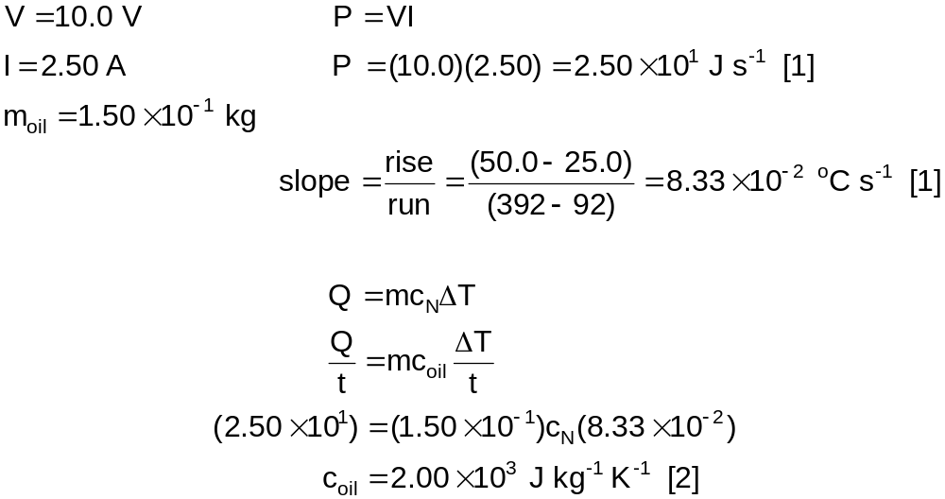
[4 marks]
5. [13 marks]
The velocity–time graph for a remote control car is shown below.
5 10 1520 time (s)
8
6
4
2
0
-2
-4
-6
-8
velocity (m s⁻¹)

B
A

a. What is the velocity and acceleration of the car at t =10s?
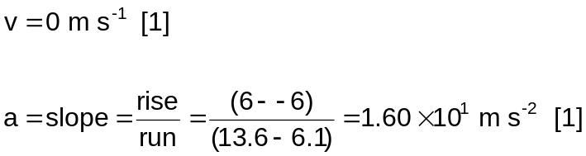
[2 marks]
b. In the space below plot a graph of the acceleration of the car against time.
[3 marks]
5 10 1520 time (s)
16
12
8
4
0
-4
-8
-12
-16
acceleratiion (m s⁻²)
Acceleration of a Model Car over Time
[1] zero from 0-5 s
[1] 16 from 5-15 s
[1] zero from 15-20 s

c. Determine the displacement of the car during the time interval from
t = 10 s to t = 20 s.
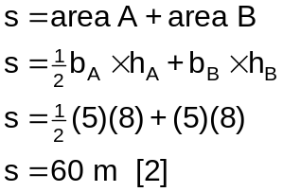
[2 marks]
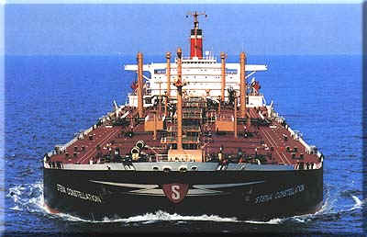
Now consider a supertanker of mass 4.00 x 10⁸ kg, cruising at an initial speed of 14.5 m s⁻¹, takes 1.00 hour to come to rest. Assuming that the force slowing the tanker down is constant;
d. Calculate the deceleration of the tanker.
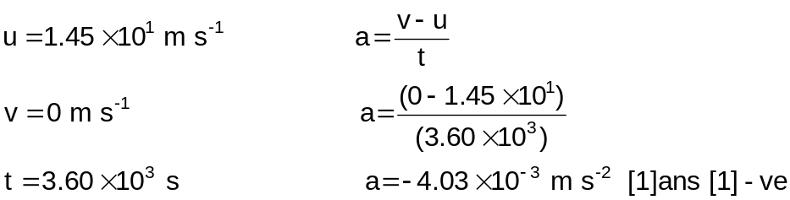
[2 marks]
e. Find the impulse (change in momentum) on the tanker while coming to rest.
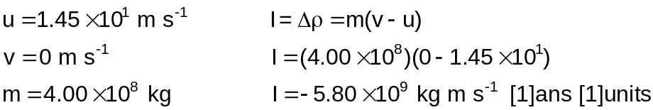
[2 marks]
f. Determine the distance travelled by the tanker while slowing to a stop.
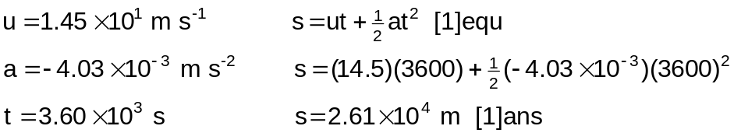
[2 marks]
g. Sketch, using the axes below, a distance-time graph representing the motion of the tanker until it stops.
[2 marks]
Displacement of Supertanker as it Comes to Rest
Distance ( x 10⁴ m)
Time ( s )
01000200030004000
2.5
2.0
1.5
1.0
0.5
0

[1] Shape
[1] Accuracy

6. [8 marks]
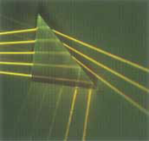
The diagram at right shows five nonparallel light rays entering a glass prism from the left hand side of the picture.
a. How many of these rays undergo total internal reflection at the slanted surface of the prism?
- two [2]
[2 marks]
b. Suppose that the prism in above can be rotated in the plane of the paper. In order for all five rays to experience total internal reflection from the slanted surface, should the prism be rotated clockwise or anticlockwise? Explain.
- The prism should be rotated anticlockwise. [1]
- As this will increase the incident angle on the second glass-air interface to be greater than the critical angle. [1]
[2 marks]
Now consider light travelling through an air-water boundary
c. Find the critical angle for an air-water boundary.
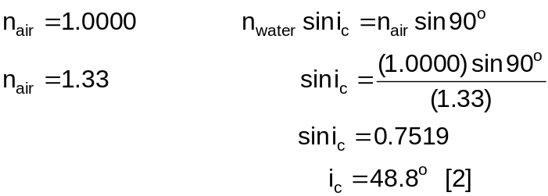
[2 marks]
d. A fish in a still pond looks upward toward the water’s surface at different angles (θ) relative to the normal, as in the Figure below? What does it see as the angle changes from 0 to 90°? Explain.
θ

- From 0° to 48.8° the fish will see above the surface. [1]
- From 48.8° to 90° the fish will see reflected images from below the surface. [1]
[2 marks]
7. [15 marks]
Charles Coulomb (1736–1806) measured the magnitudes of the electric forces between charged objects using the torsion balance.
a. From Coulomb’s experiments, what can we can generalise about the properties of the electrostatic force between two stationary charged particles.
- The electrostatic force is directly proportional to the charge of the particles. [1]
- And inversely proportional to the square of the distance between them. [1]
[2 marks]
b. The number of free electrons in 1.00 cm³ of copper is on the order of 10²³. How does this compare with the number of electrons required to produce a charge of 1.00 C?
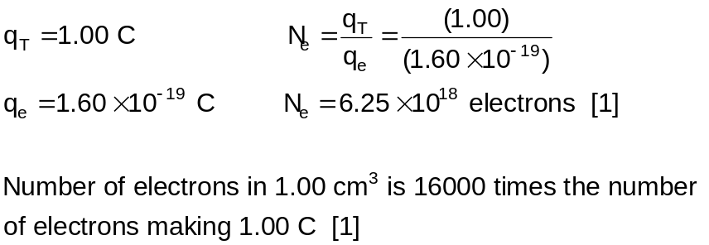
[2 marks]
c. The electron and proton of a hydrogen atom are separated (on the average) by a distance of approximately 5.3 x 10⁻¹¹ m. Find the magnitude of the electrostatic force between the two particles.
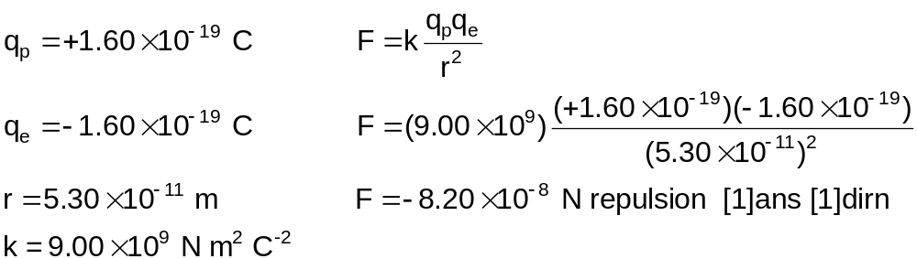
[2 marks]
d. Two identical charged spheres, each having a mass of 3.00 x 10⁻² kg, hang in equilibrium as shown below. The length of each string (L) is 0.150 m, and the angle θ is 5.00°.
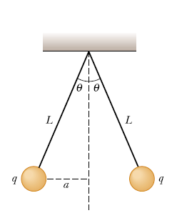i. Determine how far apart the spheres are.
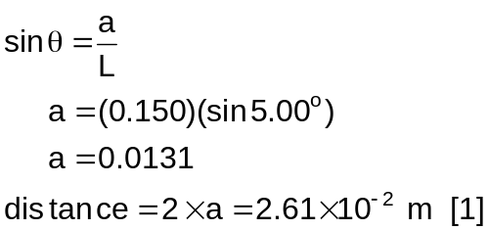
[1 mark]
ii. Choose one of the spheres and draw on the diagram below all of the forces acting on that sphere.

F_{w} [1]
F_{e} [1]
F_{T} [1]

[3 marks]
iii. From the forces identified in (ii) determine the magnitude of the electrostatic force on each sphere.
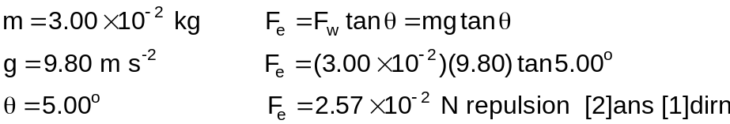
[3 marks]
iv. Are you able to determine the sign of the charge on the spheres? Explain.
- No, as the force is repulsion they could either both be positive or both be negative. [1]
[1 mark]
v. Suppose your classmate proposes solving this problem without the assumption that the charges are of equal magnitude. She claims that the symmetry of the problem is destroyed if the charges are not equal, so that the strings would make two different angles with the vertical, and the problem would be much more complicated. How would you respond?
- As the force on each sphere is equal and opposite, then despite different charges on each sphere the electrostatic force will be equal on each sphere, thus causing equal angles. [1]
[1 mark]
SECTION C: Comprehension
Marks Allotted: 40 marks out of total of 200 marks (20%)

This section contains TWO questions. You should answer BOTH of the questions.

Read the following passages and answer the questions at the end of each. Candidates are reminded of the need for clear and concise presentation of answers. Diagrams (sketches), equations and/or numerical results should be included as appropriate.

Question 1: Read the articles below and answer the questions that follow.

Geothermal
Geothermal energy is energy from the heat of the earth. It has been used for thousands of years in some countries for hot water, cooking and heating. It can also generate electricity, using steam produced from heat found beneath the surface of the earth. It is not common in Australia, but is used in some parts of New Zealand and through Europe.
When water flows over hot rocks, hot water and steam are created and escape to the earth's surface. Bubbling mud pools, hot springs and geysers are examples of geothermal energy. Volcanoes are very violent examples of this type of energy.
The hot water and steam created underground can be used to create electricity (by turning turbines) to heat homes and other buildings. The steam is collected, and used to power a generator, in the same way it is used in a coal fired power station.
The Maoris of New Zealand use hot rocks to cook food in the ground. Around the world people also swim in warm natural springs to help soothe body aches and pains.
Another form of geothermal energy is called "hot rock". This is where water is pumped below the surface to areas of hot rock. The water then turns to steam, and is pumped back to the surface to drive a turbo-generator.
Australia does not currently produce electricity from geothermal energy. However, tests are being carried out on a "hot rock" power station.
(Source: http://www.energy.com.au/energy/ea.nsf/Content/Kids+Geothermal)

The energy source
Heat is continually radiating through the Earth’s crust. This heat is derived largely from radioactive decay of crustal rocks with contributions from local thermal perturbations (activity) associated with tectonic events such as rifting. Thick sedimentary deposits and rocks trap the heat so that temperatures are higher than normal in the basement in such areas.
Certain granites contain higher than normal levels of radioactive minerals. Additional heat becomes stored in these rocks if they are insulated. The more effective the insulation, the greater the amount of heat stored; coals and carbonaceous rocks are very effective heat seals. Greater temperatures can be reached with greater thickness of cover. Burial of about 3km is necessary for temperatures in excess of 200°C. To use the stored heat effectively it needs to be transferred to the surface to power electricity generation.
The technique being tested is to drill a well into the granite and then create an artificial reservoir by hydraulically fracturing the rock. Water is pumped into the artificial reservoir, becomes superheated, and remains liquid, as it is under pressure. Production wells are used to bring the superheated water to the surface. At the surface, the superheated water is passed through a heat exchanger. The cooled water then repeats the journey to the deep granite, is reheated and returns to the surface. The water cycle is effectively a closed cycle.
Source (http://www.nrw.qld.gov.au/factsheets/pdf/mines/m7.pdf)
a. Why do you think that the use of geothermal energy in Australia is not as common as it is in Indonesia and New Zealand?
- Australia lies in the middle of a continental plate. [1]
- While Indonesia and New Zealand lay on the edge of the continental plate where the crust is thinnest and volcanic activity is greater. [1]
[2 marks]
b. Suppose water at 21.0°C is pumped into the hot rocks and steam at 100.0°C is produced at a rate of 190.0 kg per second. How much energy per second transferred is transferred from the hot rocks to the power station in this process?
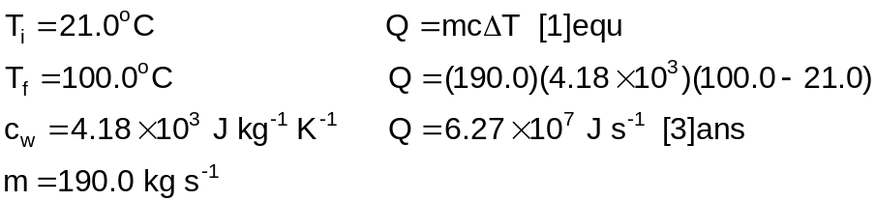
[4 marks]
c. In passage two it says “Thick sedimentary deposits and rocks trap the heat so that temperatures are higher than normal in the basement in such areas.” What do you think might be some of the characteristics of these rocks?
- These rocks must be poor conductors of heat energy. [1]
- The might also have a high specific heat capacity. [1]
[2 marks]
d. The hot rocks are estimated to have a volume of 4.00 x 10⁶ m³. Estimate the fall of temperature of these rocks in one day if thermal energy is removed from them at the rate calculated in part (i) without any thermal energy gain from deeper underground. (Assume that the specific heat capacity of the rock is 8.50 x 10² J kg⁻¹ K⁻¹ and 1.00 m³ of rock has a mass of 3.20 x 10³ kg).
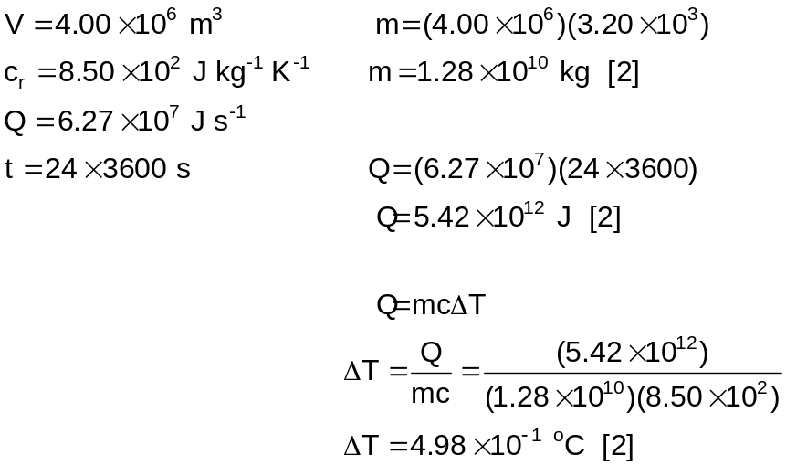
[6 marks]
e. What do you see as some of the advantages of using geothermal energy?
- Reduces carbon dioxide emission. [2] first one
- Decreases dependence on fossil fuels [1] second one
[3 marks]
f. What do you see as some of the disadvantages of using geothermal energy?
- Cost of development. [2] first one
- Use of power to pump the water, [1] second one
[3 marks]
Question 2: Read the article and letter below and answer the questions that follow
In the summer of 1939, six months after the discovery of uranium fission, American newspapers and magazines openly discussed the prospect of atomic energy. However, most American physicists doubted that atomic energy or atomic bombs were realistic possibilities. No official U.S. atomic energy project existed.
Leo Szilard was profoundly disturbed by the lack of American action. If atomic bombs were possible, as he believed they were, Nazi Germany might gain an unbeatable lead in developing them. It was especially troubling that Germany had stopped the sale of uranium ore from occupied Czechoslovakia.
Unable to find official support, and unable to convince Enrico Fermi of the need to continue experiments, Szilard turned to his old friend Albert Einstein and the eventual result was the letter below. (Note: only the first page of the letter is shown, and this is a re-creation of the original letter)
Albert Einstein
Old Grove Rd.
Nassau Point
Peconic, Long Island
August 2nd, 1939
F.D. Roosevelt
President of the United States,
White House
Washington, D.C.

Sir:
Some recent work by E. Fermi and L. Szilard, which has been communicated to me in manuscript, leads me to expect that the element uranium may be turned into a new and important source of energy in the immediate future. Certain aspects of the situation which has arisen seem to call for watchfulness and, if necessary, quick action on the part of the Administration. I believe therefore that it is my duty to bring to our attention the following facts and recommendations:
In the course of the last four months it has been made probable – through the work of Joliot in France as well as Fermi and Szilard in America – that it may become possible to set up a nuclear chain reaction in a large mass of uranium, by which vast amounts of power and large quantities of new radium-like elements would be generated. Now it appears almost certain that this could be achieved in the immediate future.
This new phenomenon would also lead to the construction of bombs, and it is conceivable – though much less certain – that extremely powerful bombs of a new type may thus be constructed. A single bomb of this type, carried by boat and exploded in a port, might very well destroy the whole port together with some of the surrounding territory. However, such bombs might very well prove to be too heavy for transportation by air.
a. Explain what Einstein meant by a “nuclear chain reaction”.
- A nucleus decays as a slow neutron strikes it [1]
- giving off two or three neutrons [1]
- each of these neutrons can induce another nucleus to decay thus a chain reaction occurs. [1]
[3 marks]
b. Explain how “vast amounts of power” can be generated from the Uranium.
- As each nucleus decays the mass of the products is less than the mass of the reactants [1]
- thus some mass is converted into energy [1]
- The energy is calculated by E=mc² so for a very small mass a relatively large amount of energy is released. [1]
[3 marks]
c. How could the new Radium-like elements, that Einstein talked about, be produced?
- As the uranium undergoes fission it breaks into two daughter nuclei [1]
- These nuclei can be radioactive like radium. [1]
[2 marks]
d. Consider the radioactive decay of the uranium isotope 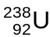. Each nucleus that decays releases 4.20 MeV of energy. Calculate the mass of , in kilograms, that must decay each second to release energy at a rate of
5.00 x 10² MW.
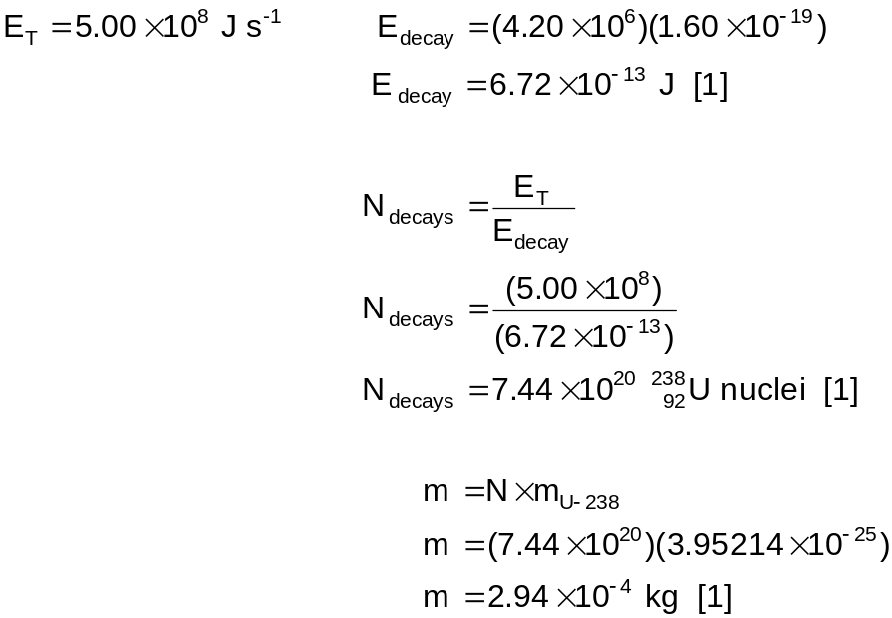
[3 marks]
e. How might the bombs that Einstein mention be constructed?
- Two subcritical masses of U-238 are positioned at the end of a tube. [1]
- An explosive charge pushes the two masses together [1]
- to create a critical mass [1]
- This mass of uranium will undergo an uncontrolled chain reaction which results in an explosion. [1]
[4 marks]
f. One of the radium-like elements produced from Uranium is Iodine-131, which is commonly used to treat thyroid cancer, probably the most successful kind of cancer treatment. It is also used to treat non-malignant thyroid disorders. Why do you think that Iodine-131 is so successful in treating thyroid cancer?
- Iodine accumulates in the thyroid [1]
- So its cancer killing effects are targeted in the thyroid. [1]
[2 marks]
g. When treating individuals with radiation, care must be taken not to confuse “Dose Equivalent” and “Absorbed Dose”. Explain the difference between these terms.
- Absorbed Dose is the quantity of energy absorbed per kilogram of body mass [1]
- Measured in greys [¹/₂]
- Dose Equivalent is a measure of the effect of the radiation on living things [1]
- Measured in sieverts [¹/₂]
[3 marks]
ACKNOWLEDGEMENTS

Section C

Question 1:
Geothermal - http://www.energy.com.au/energy/ea.nsf/Content/Kids+Geothermal
The Energy Source - http://www.nrw.qld.gov.au/factsheets/pdf/mines/m7.pdf
Question 2:
Einstein to Roosevelt, August 2, 1939 - http://www.dannen.com/ae-fdr.html

